NODE.JS LEARNING ROADMAP (FROM ZERO TO ADVANCED)
- Introduction to Node.js
- Node is a JavaScript runtime built on Chrome’s V8 engine
Runtime: an environment that can execute code.
Browser (Chrome, Firefox) is JavaScript runtime because it can run JavaScript code.
- It uses an event-driven, non-blocking I/O model.
I/O (Input/Output)
It refers to anything that involves interacting with outside world:
- Reading or writing files on disk
- Making network request (HTTP, database, APIs)
- Accessing database
These operations can be very slow, because they depend on external systems.
Blocking vs Non-blocking
- Blocking I/O: The program stops and waits until the operation finishes to move to another operation.
- Non-blocking I/O: The program does not wait. It starts the operation and continues running other code. (With the presence of callback)
Event-driven
Node.js uses event loop, which can listens for events such as (file finished reading, or HTTP request received) and triggers callbacks when those events happen.
- Everything runs on a single thread (but it can handle thousands of concurrent requests using the event loop)
Thread
It is a single sequence of instructions that CPU can execute.
- Think of it as a worker in factory
- A CPU can run multiple threads at the same time (if it has multiple cores) or quickly switch between them.
- In traditional server, the server creates a new thread to handle that connection.
- Problem: Threads consume memory and CPU resources.
- If thousands of clients connect at the same time, the server can get overloaded.
Event loop
It is a mechanism that:
- Waits for events such as (file read finished or HTTP request received)
- Dispatches callbacks when those events occur
Workflow
- Node starts executing the program from top to bottom
- When it encounters a non-blocking operation like (fs.readFile or a network request), it registers a callback with the event loop and moves on.
- Meanwhile, Node keeps running other code.
- When I/O operation finishes, the event loop picks up the callback and executes it.
- Core Modules
What are modules? They are just JavaScript file which let you split your code into reusable pieces, instead of writing everything in one big file.
Built-in or core modules: Built in Node like fs, os. Path, http.
User-defined module: your own JavaScript files.
- Require()
Used to import a module
- Module.exports
Used to export functions, object, or variable from a module
Node.js comes with built-in modules such as:
- fs: File System (reading / writing files)
Appending to a File
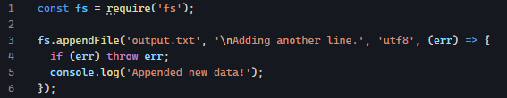
Deleting a file

- path: Working with file and directory paths
Path module helps working with file and directory paths, instead of manually concatenating strings (which can break on different OS because of / vs \), use path methods
path.join(): Combines paths safely
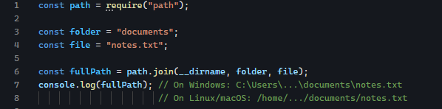
__dirname: It is an absolute path to the directory of the current file JavaScript file resides.
Absolute path means, it start from the root of the filesystem.
path.resolve(): It gets the absolute path

- os: System information (CPU, memory..)
- http: Creating web servers
What is Server?
- Server (Hardware/ Machine sense):
Powerful physical machine that stores data and runs programs, often available 24/7.
Egg: A data center machine hosting websites, apps, databases. AWS, Azure, or Google Cloud servers are these kind of machines.
- Server (Software sense):
A program that listens for requests and send back responses.
Hardware server (machine) can run many software servers.
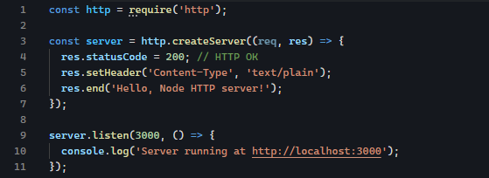
- http.createServer(): Creates web server
- (req, res): Callback runs every time a request comes in.
- Req: Contains info about the request (method, URL, header, etc)
- Res: Lets you send a response (status, headers, body)
- Server.listen(port): Starts listening for incoming connections.
Routing: handling different URLs:
Here we inspect req.url to serve different content.
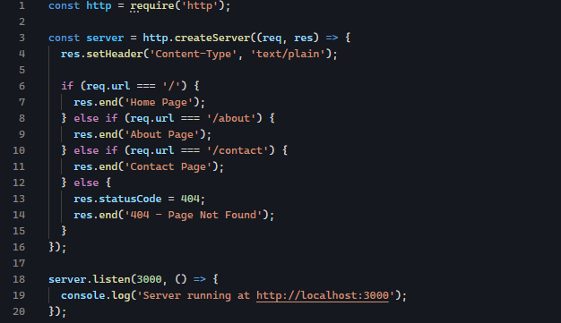
It combines both status code and headers all at once.
Content-Type header is telling the client (browser..) that the content I am sending you is one of this type, please handle it accordingly. It is an HTTP Header that describes what kind of data is in the response body.
Type | Header Value | Meaning
Plain text | text/plain | Just text, no formatting
HTML | text/html | Web page content
JSON | application/json | Structured data (JavaScript Object Notation)
Image | image/png, image/jpeg | Binary image data

- events: Handling custom events
- Asynchronous JavaScript in Node
Node is single-threaded, which means, it can only execute one piece of code at a time. But since it is non-blocking, It can move on executing operations while waiting for task to complete.
3 ways to handle asynchronous operation in Node
- Callbacks – Traditional way
- Promises – Modern way
- Async / Await – Easiest and more readable
Callback: Callback is a function passed as an argument into another function and it is intended to be called later after some operations. It is fundamental concept for handling asynchronous operations like reading files, making HTTP request. Node continues running other code while waiting for the operation to complete.
Reading file with callback:
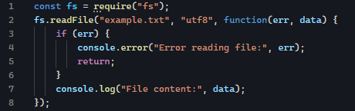
Here function(err, data), which 3rd argument is a callback. Node continues running while waiting for file reading operation to complete.
Promise: Promise is an object representing future value, It represents a value that may not be available yet. It can be in one of three states:
- Pending – Still in progress
- Resolved – Operation completed successfully
- Rejected – Operation failed with error
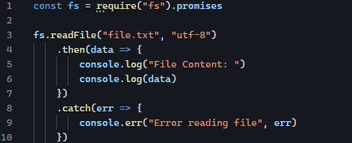
Promise object has methods .then() and .catch()
data => {…} is a callback which will be executed if the Promise resolves.
err => {…} is also callback which will be executed if Promise is rejected.
Async / Await: More readable then Promise.
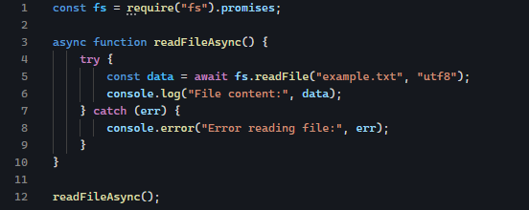
- npm (Node Package Manager)
Npm is the default package manager for Node.js and it lets:
- Install third-party packages (modules) from the npm registry
- Manage dependencies for your projects
- Run scripts for automating such as testing building servers
package.json: every node project starts with a package.json, it describes your app and its dependencies.
npm init to initialize npm or npm init -y to skip questions
Installing packages
- npm install package’s name : To install package locally, project only
- npm install -g package’s name : To install package globally, it can be accessed from anywhere.
Removing and updating packages
- npm uninstall package’s name: To remove package
- npm update packag’s name: To update package
scripts in package.json
Inside package.json, we can define reusable sripts

Then run:
npm run start
npm run dev
Undestanding Semantic Versioning
- No symbol (Locked version)
When you see a dependency in package.json like this:

There is no caret (^) or tilde (~) in front of the version. It means you are locking the package to exactly that version, no automatic updates will be installed when you run npm install or npm update
“express”: “4.17.21” ➡️only that version will be installed, npm will not automatically installed the other version.
- With caret (^)
“express”: “^4.17.21” ➡️ allows update that do not change the major version (the first number), which means npm can install anything >=4.17.21 and <5.0.0. So npm can update anything from 4.17.21 but not to 5.0.0. You get minor and patch update.
- Compare with tilde (~)
“express”: “~4.17.21” ➡️allows patch update only, meaning >= 4.17.21 and < 4.18.0. So it can install 4.17.22 or 4.17.25 but not 4.18.0
- Building a Simple HTTP Server
HTTP server is software that can listen for incoming HTTP request (like when you visit a website) and sends responses back to the clients (like HTML, JSON, text, etc..)
- Basic example
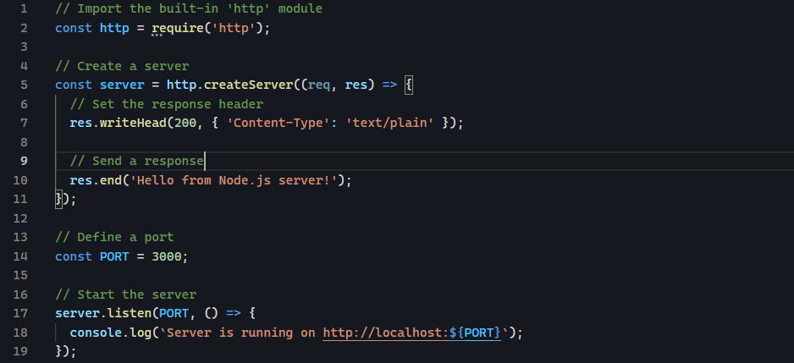
- Handling different routes
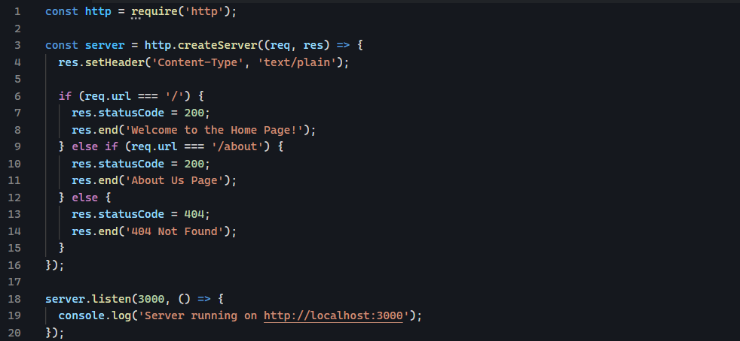
- Sending Html Content
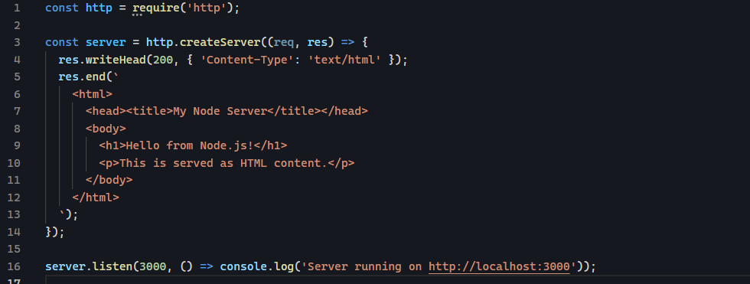
- Serving JSON
For API we often send JSON
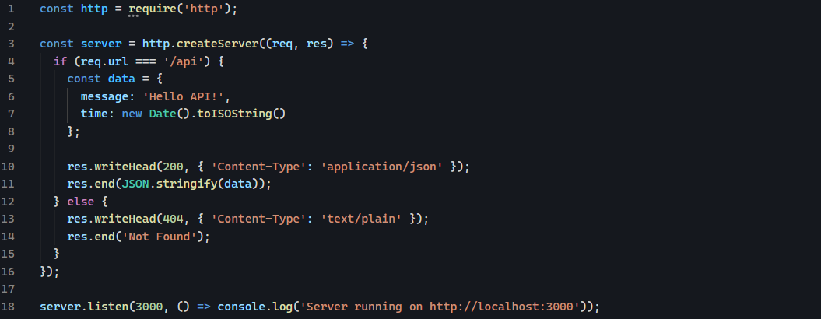
- Working with JSON and APIs
Working with JSON Locally in Node.js
- What is JSON
JSON: JavaScript Object Notation which is used for storing and exchanging data.
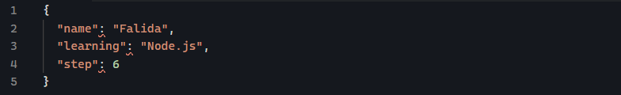
- Reading JSON file
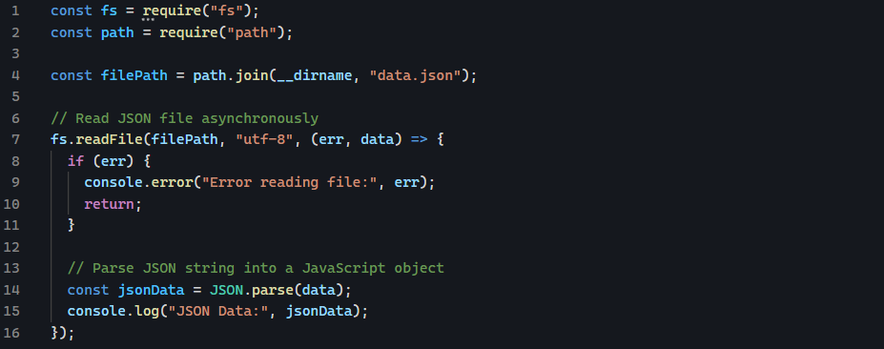
- Writing JSON files
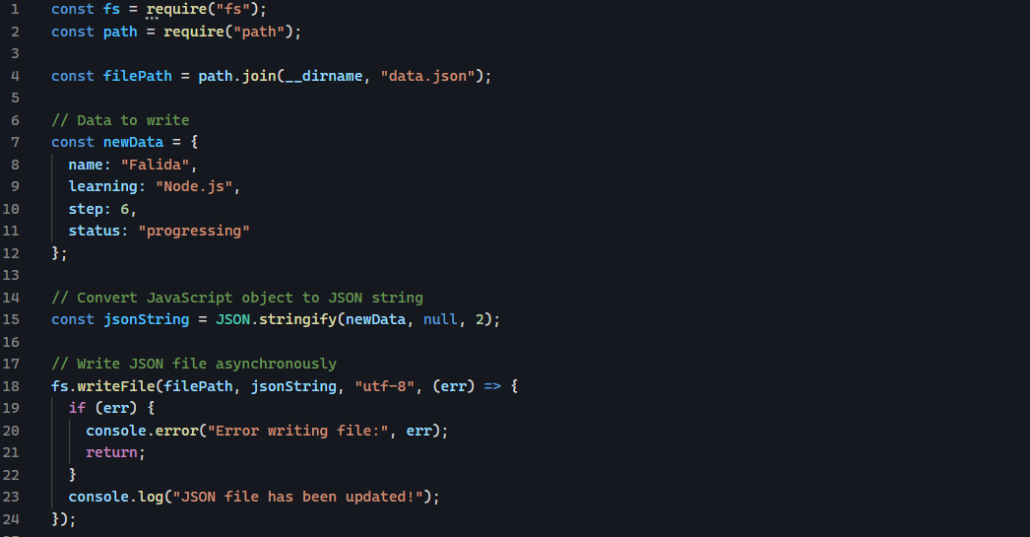
Working with External APIs in Node.js
- What is an API
It stands for Application Programing Interface. It’s a way for 2 applications to talk to each other like Node.js ap talking to server on the internet.
- Making API request in Node.js
- Using built-in https module
- Third-party library like node-fetch and axios
Using node-fetch
Install package node-fetch like npm install node-fetch
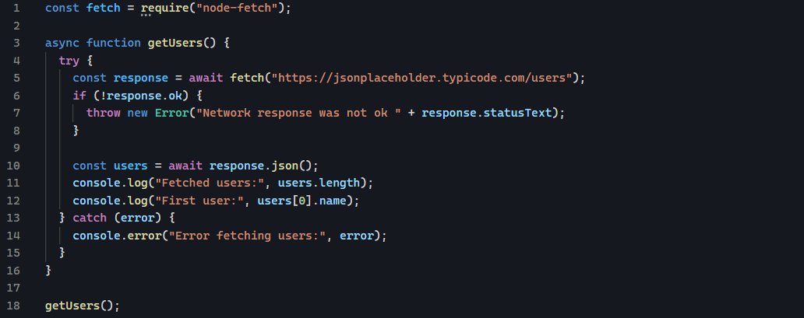
- Fetch makes a network request to the given URL, it returns a promise so we have to use await.
- Response is a Response object , not a plain text or JSON
- Response.json() is a method built into response object. It reads the response body stream and converts it into JavaScript object for you.

- Error Handling & Debugging
- Environment Variables & Config
- Express.js Fundamentals
  - What Express.js is & setup
Express is a minimal and flexible web framework built on top of Node.js.
It provides powerful tools for:
- Creating web server easily
- Handling routes (URLs)
- Managing HTTP request and responses
- Using middleware to add extra logic (like authentication, logging, etc)
- Building APIs (like RESTful APIs) that send and receive data (usually JSON)
  - Creating your first server
Basic Server
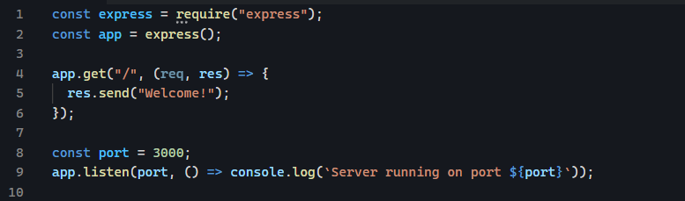
Handling Different HTTP Methods
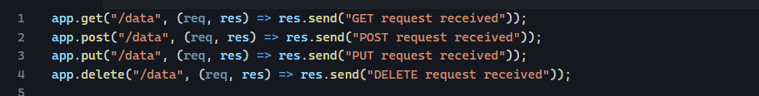
- GET ➡️ Read data
- POST ➡️ Create new data
- PUT ➡️ Updating existing data
- DELETE ➡️ Remove data
Sending responses
Express provides multiple ways to send responses:
- Res.send(): to send text, html, or buffers (raw bytes [72, 101, 108, 111])
- Res.json(): to send JSON data, automatically sets Content-Type: application/json
- Res.status(): sets the HTTP status code
Understanding req and res
Req(request) ➡️ info about incoming request
- req.method ➡️ HTTP method(GET, POST, etc)
- req.url ➡️ Requested URL
- req.params ➡️ Route parameters
It is value extracted from the URL path itself, defined in your route. It is defined with : in route path.
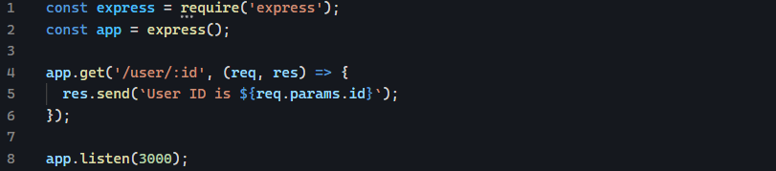
Here: req.params is always an object like this
URL: http://localhost:3000/user/123
req.params → { id: '123' }
- req.query ➡️ Query strings
it is values in the URL after ?, also called query strings. It is part of URL ; you do not define them in the route.

URL: http://localhost:3000/search?q=express
req.query → { q: 'express' }
- req.body ➡️ Body data (needs middleware to parse JSON or form data)
res(response) ➡️ methods to respond to the clients
- res.send() ➡️ sends text or HTML
- res.json() ➡️ sends JSON
- res.status() ➡️ sets HTTP status
- res.redirect ➡️ redirect to another URL
- res.end() ➡️ ends response (usually called automatically by res.send())
  - Understanding routing
Routing is how Express app decides what code to run for a given URL and HTTP method. It defines how your server responds to a specific HTTP request made to a specific path (URL)
What is a route?
A route in express defines:
- An HTTP method (GET, POST, PUT, DELETE, etc.)
- A path (like /users or /products/:id)
- One or more handler functions that run when route is hit
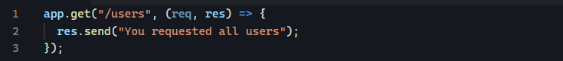
Route chaining (optional)
If you want to handle multiple methods for the same path, you can chain them:
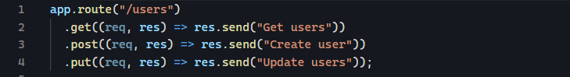
Organizing routes using express.router()
When your app grows, having all routes in server.js becomes messy. Express provides a Router to modularize (split into smaller, self-contained pieces, organizing your code into separate modules (files)) routes.
Routes/users.js
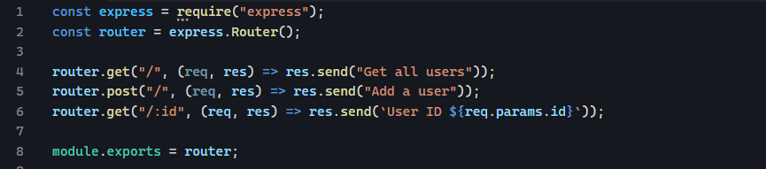
  - Middleware (built-in, custom, third-party)
In Express.js, middleware functions are functions that have access to request (req), response (res), and the next middleware function in the application’s request-response cycle.
They can:
- Execute code
- Modify the request or response objects
- End the request-response cycle
- Call the next middleware in the stack using next(). If middleware does not call next(), the request will be stuck and never move on to the next handler.
Anatomy of a middleware
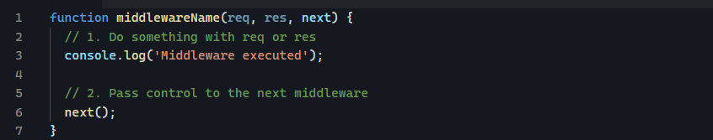
What is differences between middleware and route handler?
Feature | Middleware | Route Handler
Purpose | Process request/response before final handling | Send the final response
Calls next()? | Usually yes | Usually no
Can modify req / res? | Yes | Yes
Ends the request-response cycle? | Sometimes | Yes (typically)

Middleware flow (request – response cycle)
- Built-in middleware
Middleware | Purpose
express.json() | Parses incoming JSON payloads
express.urlencoded() | Parses form data from x-www-form-urlencoded requests
express.static() | Serves static files (HTML, CSS, JS, images)


- Custom middleware
you can create your own middleware to perform specific tasks such as:
- Loggin request
- Authentication
- Validating inputs
- Attaching user data to req
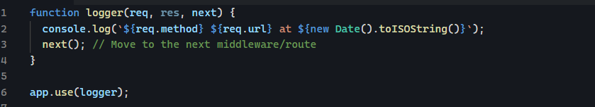
Route specific middleware
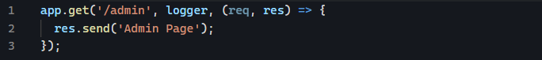
- Third-party middleware
Such as : cookie-parser, express-session …..
Application-level vs router-level middleware
The following is application-level middleware as it applies to the entire app.
The following is router level middleware
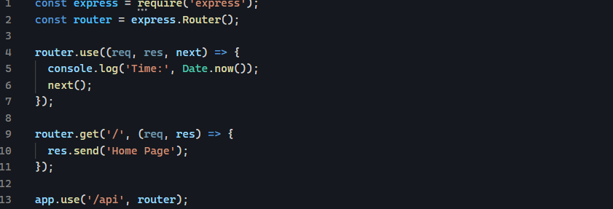
Any request starting with /api will use the router middleware
Error handling middleware
It has four parameters (err, req, res, next)
If any middleware or route calls next(err)
Where err is anything that’s not undefined, Express interprets it as an error and skips all remaining non-error middleware. It jumps straight to error-handling middleware (functions with 4 arguments).
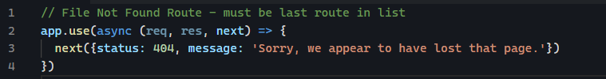
Global error-handling
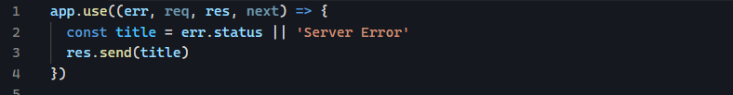
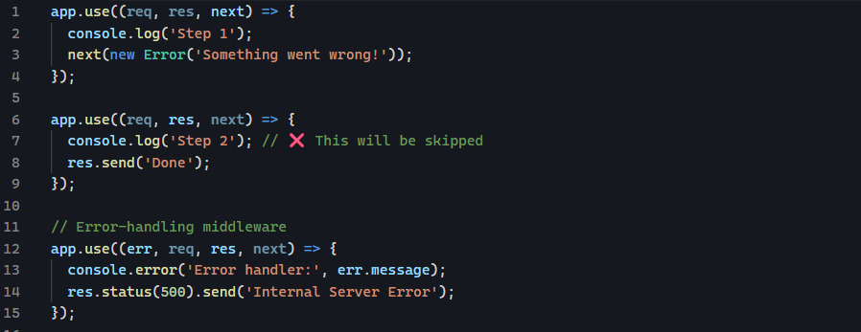
Concept | Explanation
next(err) | Tells Express that an error occurred
Error handler signature | (err, req, res, next)
Behavior | Skips all normal middleware and jumps to this function
Typical response | `res.status(err.status

Difference between new Error(‘Something’) and Throw new Error(‘Something’)
- new Error('Oops!')

This simply creates an error object, but it does not throw or stop execution. As in the example below, it can be passed to Express next().
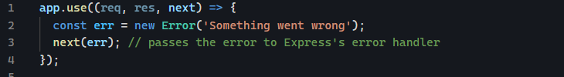
- throw new Error('Oops!')
it does 2 things: it creates Error object and immediately throws it, which means it interrupts execution and must be caught by try .. catch or an error-handling system.
Middleware order matters as Express executes middleware in order they are defined
- conditional middleware
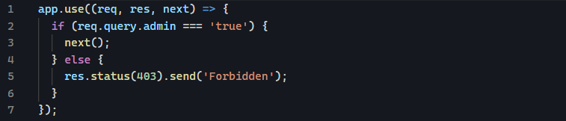
  - Request & response objects
When a client (browser, API tool, frontend app, etc.) makes a request to your express server, Express gives you access to two important objects:
- req ➡️ Request Object
it contains all information sent from the client such as:
- URL
- HTTP method
- Headers
- Query parameters (e.g., ?name=john)
- Route parameters (e.g., /user/:id)
- Body(JSON, form data)
- Cookies
- IP, protocol, etc
- res ➡️ Response Object
- res.send() ➡️ send text, JSON, HTML
- res.json() ➡️ send JSON
- res.status() ➡️ set HTTP status code
- res.sendFile() ➡️ send a file, with absolute path as argument
- res.redirect() ➡️ redirect to another URL
- res.set() ➡️ set response headers
important things about req & res
req object (commonly used properties):
Property | Description
req.query | Query parameters
req.params | Route parameters
req.body | Body from POST/PUT/PATCH
req.headers | HTTP request headers
req.method | GET/POST/etc
req.url | URL path
req.ip | Client IP

res object (commonly used methods):
Method | Usage
res.send() | Send any response
res.json() | Send JSON
res.status(code) | Set status code
res.set(header, value) | Set a header
res.sendFile() | Serve a file
res.redirect(url) | Redirect

  - Serving static files
Express makes it very easy to serve static content such as:
- HTML file
- CSS
- JavaScript (client-side)
- Images
- Videos
- PDFs
- Any front-end assets
Static files are handled using built-in middleware
This means express will automatically look inside public folder and any file inside it becomes accessible from the browser, no route is needed.
  - Handling forms & JSON
- Handling Form Data (HTML Forms)
When you submit an HTML form like this:
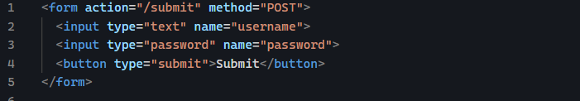
The browser sends the data using:
Express needs middleware to read it:
Example route for handling Form Submission
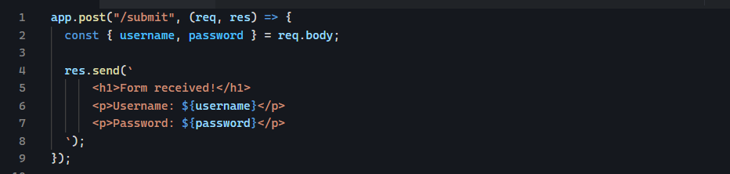
Now express can read form inputs via req.body
- Handling JSON Data (API Requests)
When JavaScript sends JSON:
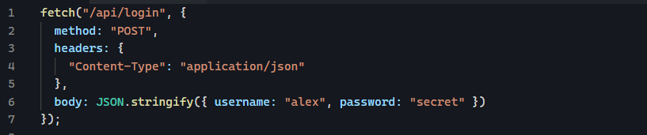
Express needs:
Example JSON route
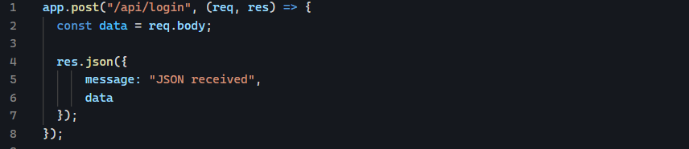
You should place these at the top of your server:
What happens behind the scenes?
- Express reads the raw request body
- Parses it
- Converts it to JavaScript object
- Stores it in req.body
- Your route handlers can access it easily

  - Organizing routes & project structure
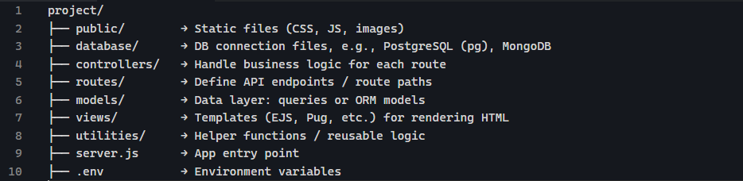
  - Error handling in Express
- Basic Error Handling in Express
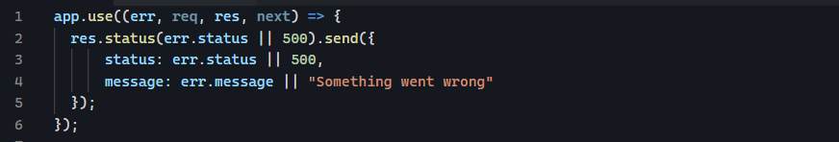
- Robust Error Handling to handle async error
The Problem
In Express, when you have async route like this:
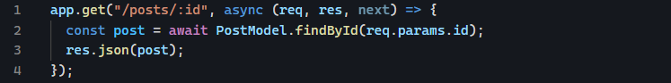
If findById fails, the promise rejects, Express does not automatically catch rejected promises, you must wrap it in try/catch and call next(err)
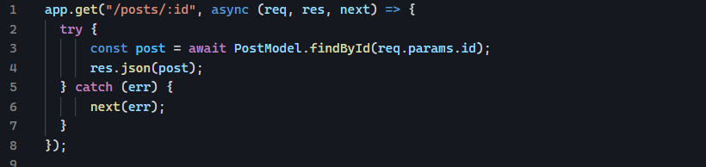
Writing this try/catch for every route is repetitive
The High-Order Function Solution
- fn ➡️ your original async route
- returns a new function(req, res, next)
- wraps fn in Promise.resolve(..).catch(next)
This is the same as
In Promise .then() is optional, it is only needed if you want to do something with the resolved value
Why Promise.resolve()?
It ensure that whatever you pass becomes a promise
- if value is already a promise, it just returns that promise
- if value is not a promise like a normal functions, it wraps it in a resolved promise
- Building RESTful APIs
- Middleware, Routing, Templates
- Databases (MongoDB / SQL)
- Authentication (JWT / Sessions)
- Testing & Deployment

